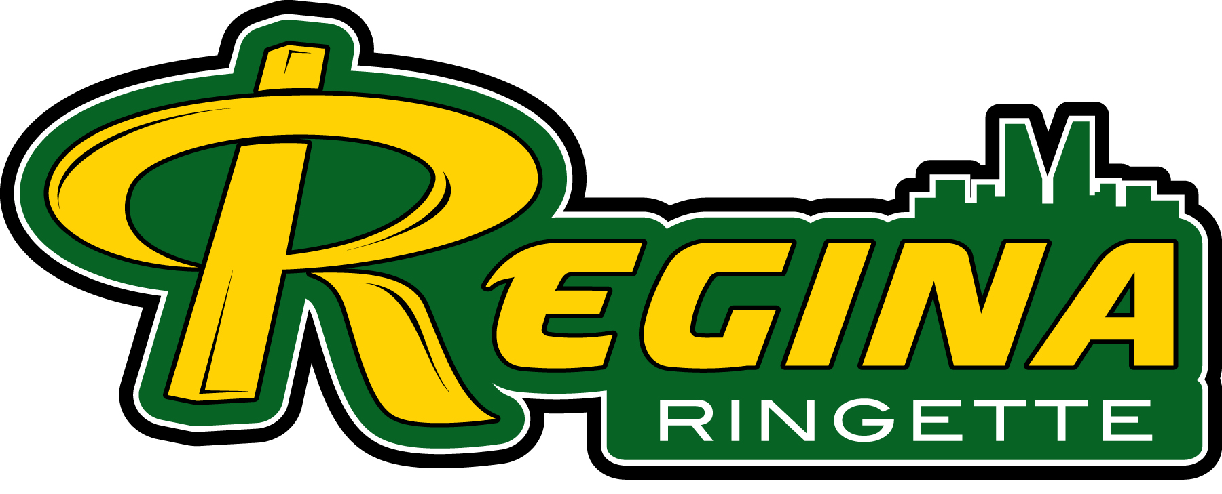
Regina Ringette Association
Board Meeting Agenda
July 5, 7:30pm via zoom

EXECUTIVE | BOARD MEMBERS
President  Mike Wiens | Coaching  Melanie Muckelt | U12 and U14  Nicole Fisher
Vice President / ROAR  Paul Kozan | Equipment  Neil Stang | U16  Jason Hoffart
Secretary  Darla Larson | Marketing  Darin Degenstein | U19  Trish McBeth
Treasurer/Registrar  Rae Lenz | Player Development  Craig Cullins | 18+ (Open)  Chelsie Coxford
Website
Jenn Shupe
Children’s Ringette
Michelle Burnett
- Call Meeting to order
- Additions to Agenda
- Adoption of Agenda
- Adoption of Minutes – June 7, 2021
- Treasurer Report & Finance Committee (Rae – 5 mins.)
  - Rae is looking for 2 approvals 1) board approval of the budget forecasted items; 2) approval to proceed with the Finance Committee
- New Business
  - RRA Board Meeting Policy & Procedure (Mike)
  - RRA Basecamp Policy & Procedure (Mike)
  - Scheduling – ice shortage & what are our scheduling priorities; note the document posted titled Hours demanded & available for Aug & Sept. (Karen)
  - Conflict of Interest Policy (Darla)
  - HockeyShare – Motion: Mel – to give CR and U12B free access to HockeyShare for the 21/22 season.
  - Strategic Planning Session (Mike)
    - July 23, 24
    - Wayne to facilitate
  - Goalie Camp (Craig)
  - 3 on 3 (Craig)

- Reports
  - Registration Update
  - Webmaster - TeamLinkt Update
  - Covid 19 Committee (Jason)
  - Dir. Of Coaching
- Next Meeting –August 2, 2021 (this is the holiday Monday)
- Motion to Adjourn

