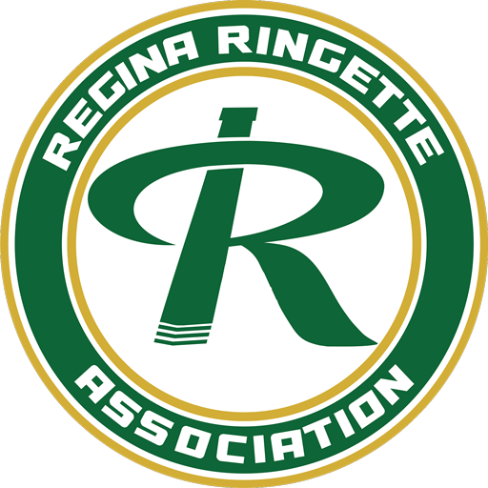
Regina Ringette Association

The Robyn & Grant Wilson Family Scholarship

The Regina Ringette Association is pleased to partner with the Wilson Family for this $1000 academic scholarship award.
To be eligible for this scholarship you must:
- Be a ringette player registered with the Regina Ringette Association or the University of Regina Cougars, with preference given to members of the Cougars program.
- Demonstrate a commitment to giving back to the sport through volunteering (e.g., junior coaching, organizing or leading camps, participating in Come Try Ringette initiatives, on-ice volunteering at tournaments, etc.).
- Be entering or enrolled in a program in science, technology, engineering, mathematics, health sciences, or business at the University of Regina.
Applications must include
- Proof of acceptance into an undergraduate program in science, technology, engineering, mathematics, health sciences, or business at the University of Regina
- A current resume outlining academic, athletic, and community involvement
- Two reference letters from ringette coaches
- Verification of volunteering in ringette (e.g., junior coaching, organizing or leading camps, participating in Come Try Ringette initiatives, or on-ice volunteering at tournaments).
- A photo for publication (if selected)
Applications must be received by the Regina Ringette Scholarship Selection Committee by December 15th, 2025.
Email completed applications, including ALL supporting documents, to reginaringette.vicepresident@gmail.com

To complete: TAB through the various fields, press SPACE BAR or click to fill in the Check Boxes.
APPLICANT
First Name |  | Last Name
Address
City | Province |  | Postal Code
Phone # | E-mail:

DECLARATION OF STUDENT ELIGIBILITY
Name of Institution
Program/Major Area of Study:
Current Class List:

RINGETTE INVOLVEMENT
_{Current} | _{Past} | Check all that apply – both current and/or past, if applicable
 |  | Player: Have you been suspended in the current Season?
Coach Certification #:
CSI (Level 1) CI (Level 2) Level 3 Have you been suspended in the current Season?
 |  | Manager Certification #:
 |  | Trainer Certification & Expiry:
 |  | Official Level:
 |  | Certified Skill Instructor
 |  | NCCP Course Conductor
 |  | Regina Ringette Association Board Member
 |  | Volunteer (list events)

RINGETTE PLAYING EXPERIENCE
Year | Team | Division | Association | Highlights

RINGETTE COACHING/STAFF EXPERIENCE
Year | Team | Division | Position
current

APPLICANT’S DECLARATION
I hereby declare that the above information, to the best of my knowledge, is true and complete and that in return for any assistance provided I will undertake to fulfill the expectations as outlined by the Regina Ringette Association.
I have enclosed the following information with my completed application form:
- proof of enrolment at a post-secondary institution
- transcript of marks
- two letters of reference
- photo
- resume outlining ringette/community involvement and extra curricular activities

Applicant’s signature: Date:
Applications must be received by the Regina Ringette Scholarship Selection Committee by December 15th.

